**The Grapple-Shot:**

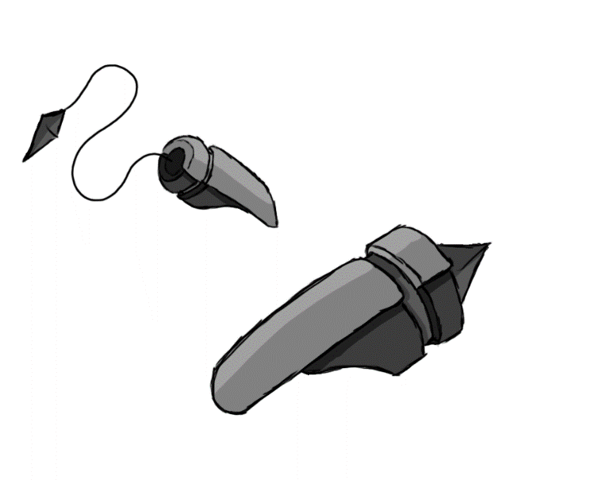

Figure - Weapon: Grapple-Shot

**Brief Synopsis**

The grapple-Shot is a weapon used by the player; it acts as the long-range weapon of the game. Of all weapons the grapple-shot has the largest range, this is countered by its exceptionally narrow arc of attack only attack enemies directly in front of the player. The main use for the grapple however is its ability to pull either an enemy too the player or pull the player to an enemy.

**Special Ability**

**Grapple:**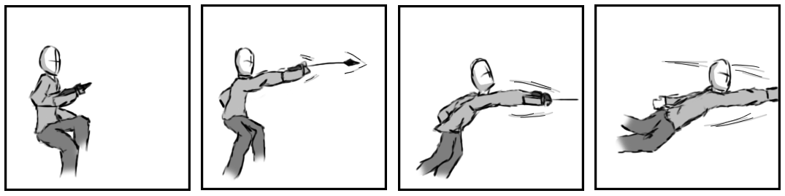

Figure 2 - Animation Storyboard: Grapple

**Special:** This has the player shoot and pull themselves to an enemy. When aerial an icon will appear over the nearest enemy within the grapples range, if the grapple button is pressed the player will grapple the enemy and pull themselves towards it. By pressing jump or attack while there being pulled forward the player will either release the grapple and jump on the enemy or kick the enemy once they reach it.

**Combat Ability’s**

**Piercing shot:   
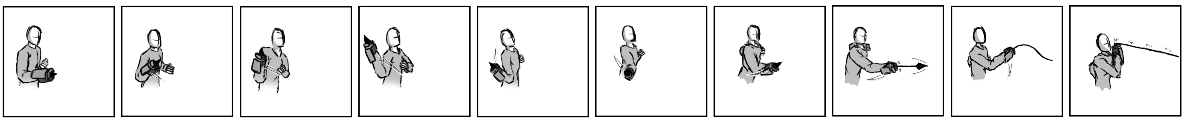  
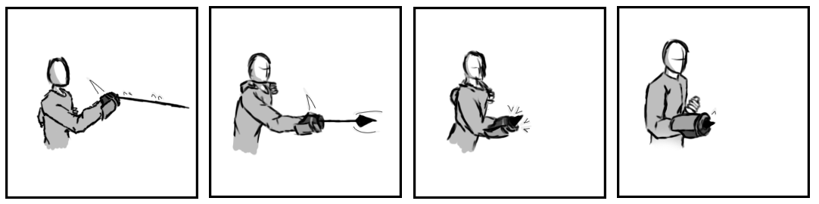**

Figure - Animation Storyboard: Piercing shot

**While grounded and stationary**: The player swings the gauntlet and fires it at the peak of its arc (forward). This will send a ranged projectile directly in front of the player attacking the first enemy it encounters.

**Extended Tether:  
  
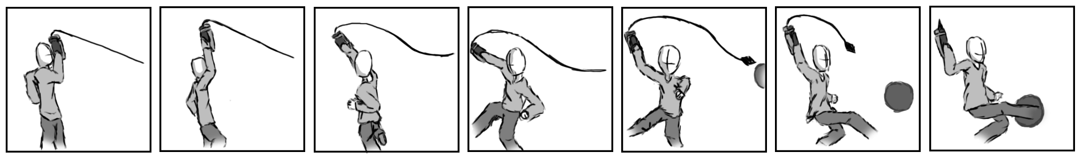**

Figure - Animation Storyboard: Extended Tether

**While grounded and in motion:** Identical to the Piercing Shot attack however if an enemy is within range it latches on and pulls it towards the player, stopping just before they reach them. If the player presses attack during the frames the enemy is moving towards the player, they will instead be pulled completely to the player where the player will then follow up by attacking with a kick.

**Whipcrack:   
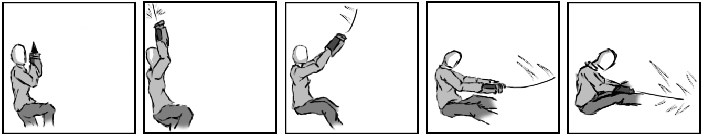**

Figure 5 - Animation Storyboard: Whipcrack

**While aerial:** The player shoots upwards followed by pulling the cord of the grapple straight down, as if using a whip. All enemies in the direction the player is facing will be stuck.